INTERN PROJECT REPORT

“Survival Time of Cancer Patients Based on Stage at Diagnosis”

Submitted by
Akshay
Intern, M.Sc Statistics
Panjab University, Chandigarh

Under the guidance of
Dr. Chander Shekhar
Professor, Department of Fertility & Social Demography
International Institute for Population Sciences (IIPS), Mumbai

Submitted to
International Institute for Population Sciences (IIPS)
Mumbai, India
July 2025

Abstract

This project analyzes the survival patterns of cancer patients using Kaplan-Meier survival analysis, Life Table analysis, and Cox proportional hazards regression. The dataset includes 100 patients with various cancer types and stages. Survival times were recorded in days, with status coded as 1 for death and 0 for censored (alive or lost to follow-up). The median survival time was approximately 1330 days. Survival probability declined steadily, with the final survival estimate approaching zero by the end of the follow-up period. Cox regression identified cancer stage as a significant predictor of survival. These findings underscore the importance of early detection and staging in improving cancer outcomes.

Introduction
Survival analysis is a statistical method used to estimate the time until an event of interest, such as death, occurs. In oncology, it helps understand patient outcomes and the effectiveness of treatment based on various factors like cancer stage. This project uses Kaplan-Meier survival analysis to estimate and compare survival probabilities of cancer patients over time, based on data from a publicly available cancer survival dataset.

Dataset Description
The dataset contains information on 100 cancer patients, including demographics, cancer type and stage, diagnosis date, last contact date, survival days, and status. The survival status was coded as 1 for deceased and 0 for censored (alive or lost to follow-up).

Methodology
Survival analysis was performed in SPSS using data obtained from Kaggle to study cancer patient survival based on age, gender, cancer stage, and cancer type. Kaplan-Meier estimation was used to calculate survival probabilities and identify the median survival time. Group comparisons were made using the log-rank test. Life Table analysis, using 100-day intervals, provided survival estimates at fixed time points. Cox regression was used to assess the impact of multiple covariates, such as age, gender, and cancer stage, on survival time.

Results
Survival analysis was conducted on a sample of 100 cancer patients using SPSS. Three survival analysis methods were applied: Kaplan-Meier estimation, Life Table analysis, and Cox proportional hazards regression.

1. Kaplan-Meier Survival Analysis
Kaplan-Meier estimation was used to calculate survival probabilities over time and to construct the survival curve.The time variable was Survival_Time_Days, and the event variable was Status, where 1 indicated death and 0 indicated censoring.
Key findings:
- At approximately:
- 100 days, survival probability ≈ 0.980
- 500 days, survival ≈ 0.781
- 1000 days, survival ≈ 0.637
- 1300 days, survival ≈ 0.502
- The median survival time is around 1325–1340 days, where the cumulative survival falls just above and then below 50%.
- By the end of follow-up (around 2700 days), the cumulative survival dropped to ~6% (0.063).

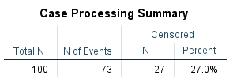

Survival Table inserted as icon or attached below
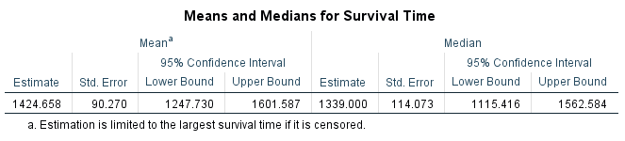

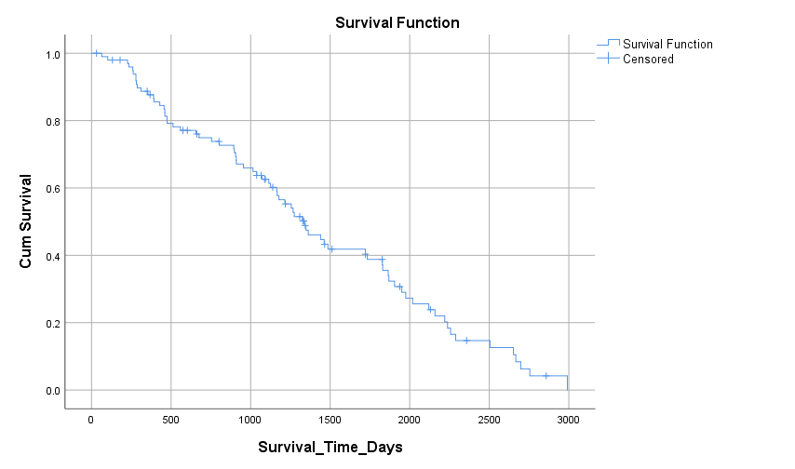

Interpretation
The Kaplan-Meier analysis shows a steady decline in survival over time, with a notable drop between 1000 and 1300 days. The final survival probability (~6%) reflects substantial long-term mortality. These findings align with the Life Table and Cox regression results.

Life Table Analysis
A Life Table analysis was conducted using 100-day intervals to assess survival across evenly spaced time periods. The table displayed the number of individuals at risk, the number of events (deaths), and survival probabilities for each interval.
Key Observation:
- Survival probability was high in early intervals (~0.98 at 100 days).
- By 1000–1100 days, cumulative survival dropped below 65%.
- By the 1328-day interval, survival probability fell below 50%, marking the median survival.
- In the final interval (2900 days), survival probability neared 0%

Life Table inserted as icon or attached below

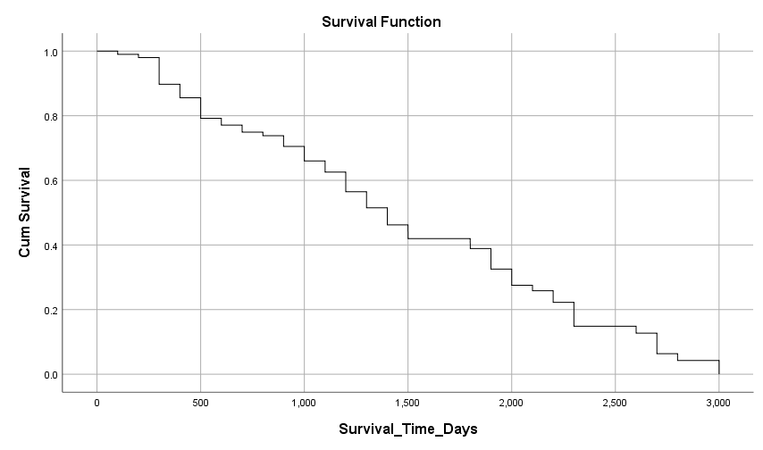

Interpretation
The Life Table analysis confirms a gradual decline in survival probability, consistent with the Kaplan-Meier findings. The median survival point (around 1328 days) indicates that half of the study population had died by this time. The near-zero survival probability in later intervals highlights the cumulative impact of cancer over time.
.

Cox proportional Hazards Regression
A Cox regression analysis was conducted to examine the effect of [independent variables, e.g., age, gender, treatment group] on the survival time measured in days. The event was defined as Status = 1 (death), and time was recorded as Survival_Time_Days.
- The overall model was not statistically significant.
- However, cancer stage (specifically Cancer_Stage_Code) was a significant individual predictor (p = 0.033, Exp(B) = 0.41), suggesting a lower hazard of death for certain stages compared to the reference.
- Other variables (age, gender, cancer type) were not statistically significant.
- The survival curve at the mean of covariates showed a steady decline over time.
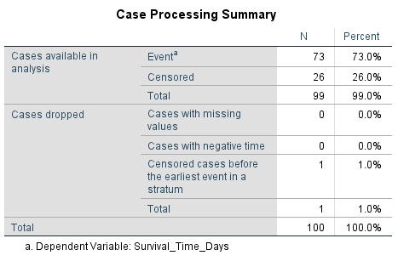

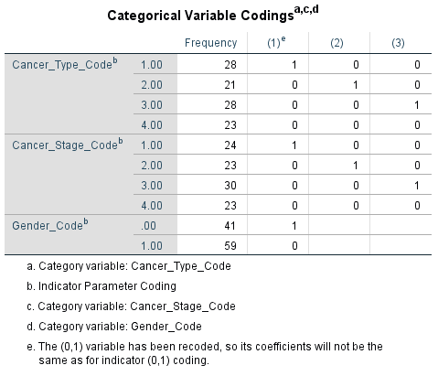

Block 0: Beginning Block


Block 1: Method = Enter
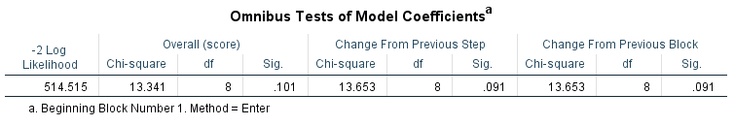

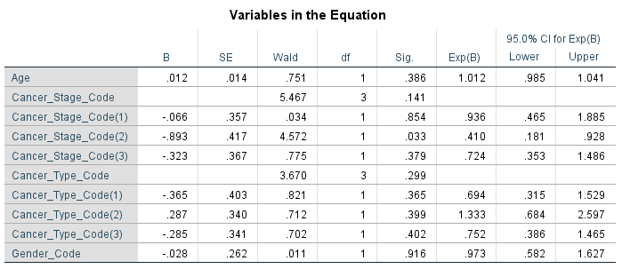

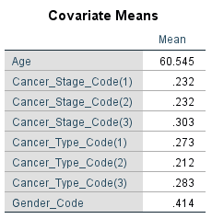
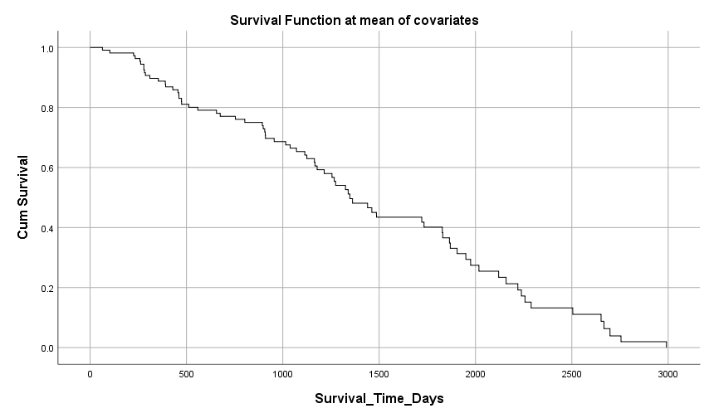

Interpretation
The Cox proportional hazards regression revealed that cancer stage was a statistically significant predictor of survival (p = 0.033). The hazard ratio for Cancer_Stage_Code was Exp(B) = 0.41, indicating that patients in this stage had a 59% lower hazard of death compared to the reference group. This suggests that individuals diagnosed at this stage had a significantly better survival outcome.
Other variables such as age, gender, and cancer type did not show significant associations with survival in this model. This implies that, within this dataset, cancer stage is the most influential factor determining survival time.
The overall model, while not statistically significant as a whole, still highlights the strong individual effect of cancer stage on patient prognosis. This reinforces the clinical importance of early-stage diagnosis in improving survival rates for cancer patients.

Conclusion
Kaplan-Meier and Life Table analyses revealed a steady decline in survival probabilities among cancer patients, with a median survival time of approximately 1330 days. Cox regression identified cancer stage as a key factor influencing survival. These findings highlight the importance of early diagnosis and ongoing monitoring to improve patient outcomes.

References
- Kaggle. (n.d.). Cancer survival dataset. Retrieved from https://www.kaggle.com
- Parmar, M. K. B., & Machin, D. (1995). Survival analysis: A practical approach. Wiley.

